Impact of Corporate Ownership on Single Family Home Sales
A repeat sales analysis of Saint Louis County

Jeremy R. Groves
Northern Illinois University
Department of Economics
jgroves@niu.edu

Version: March 16, 2026

WORKING: DO NOT CITE; DO NOT CIRCULATE

Introduction
As cities, states, and the federal government focus on the problem of affordable housing, one possible villain being identified is the corporate investor/owner. Ever since the 2007 housing crisis, many reports have pointed to the increase in the share of single-family homes being purchased by corporate entities and mused about their impact on the overall housing market. A Pew report () in 2021 focusing on Massachusetts found that seventeen percent of all homes sold in the state were purchased by investors. While this is below the national average of twenty-four percent, that national average grew nine points from 2015. Redfin also produced a report showing that of all the homes purchased in the fourth quarter of 2021, more than eighteen percent were by investors. The over arching concerns with investor purchases include the fact that investors seem to gravitate to lower-income neighborhoods and thus may block first-time home buyers in those neighborhoods, the rules governing LLC’s within the US may provide an escape for investors and an incentive to forego maintenance of properties, and that corporations are in a much better position, in tight housing markets, to make cash purchases which are clearly preferred by sellers.
The response to this has been numerous bills being proposed in state houses across the US to limit the ability of corporations to purchase homes in large quantities by either banning such behavior, withholding tax and other benefits from such owners, or restricting the use of short-term rentals (Waters, 2023, HUD Report). Are these responses warranted on economic grounds? From an economics ground there must be some source of market failure, be it collusion (), limited competition, or externalities, or a significant equality gain to warrant further government intervention in housing markets. Surprising, despite the fact of corporate ownership increasing since 2000 and especially after the 2007 housing crisis, there is little economic research on the topic and most of that literature is the census tract level were finding evidence of such market failures or equity concerns is harder to observe.
To address this gap in the literature, this paper investigates the impact of changes in ownership tenure of both the home that is sold on its value and how changes in the surrounding neighborhood of home ownership and tenure impact the value of a given home. Using data spanning from 2000 through 2020, I use individuals’ sales of homes located in Saint Louis County, Missouri, to estimate a repeat sales model to estimate the impact of how the price change of a given home is impacted by how a change in tenure and ownership status (private vs. corporate) impact the change in value and, using buffer zones of ¼, ½, and one mile radius measure how changes of tenure and ownership status of the surrounding homes, as measured by data from the County Assessor, impact the change in value.

Related Literature
One area of study in economics, but mostly sociology, stems from what Dietz and Haurin (2003) call a “general consensus” that owner-occupiers take better care of their homes than nonowner-occupiers. Travis (2019) divides nonresident ownership into five groups ranging from LLC, Corporations, limited partnerships, real estate owned, and sole proprietors in the Milwaukee area and estimate the likelihood of a code violation being reported to the Department of NS. Estimating a limited probability model with OLS, the author finds that LLC ownership predicts a two-percentage point higher likelihood of observing a code violation and that properties in black and poor neighbors also see higher likelihood of code violations. [Need more from this study]
Ross and Harris (2001) in an earlier study looking at code violations in New York find that about twenty-five percent of absentee landlords had code violations and that rate was slightly higher for multi-unit homes. In contrast, two-unit, owner-occupied buildings (where the owner lives in one unit and rents out the other) only saw about 13.5% code violations, however, for structures with three or more units, that lower violation rate disappears and even gets larger as there are more units in the structure. The effects, however, shrink when the overall value of the home is controlled for in the model. Overall the paper finds that corporate ownership is no better or worse than any other absentee landlord type ownership.
Basically three bands of literature to date
Using data on code violations, studies look at differences in the frequency of reported code violations for different tenure types.
Theorteical modeling of how institutional investors may impact the welfare of cities and renters.
Esitmates of how opportunity zone designation impact the value of homes within that census tract.

Data
The main source of data for his paper is from the Saint louis County Assessor’s office and is based on the property tax rolls for the years 2000 through 2025. This data is supplemented with data from the GIS offices within the county and the American Community Survey 5-year datasets. Further verification was carried out using the property lookup feature hosted by the Saint Louis County Assessor’s office website.

Ownership Data
Within the property tax rolls is both location and ownership information for all parcels located within the county. While there is more detailed information for all properties across the several files that make up the property database, we focused on the primary parcel data which denotes the unique parcel identification number, the tenure of the property (owner versus nonowner occupied), the property classification, and the names and addresses of the owners as recorded by the assessor’s office.
On average, there are about 396,000 parcels of land with information in each year of the database and we denoted the tenure of the parcel as owner if the property address matched the owner’s address. After filtering out the non-owner parcels, we use regular expression searches of the property owner’s names to identify the type of owner of each parcel across all property classes. This was carried out as an iterative process starting with the more obvious cases of ownership types. For example, if “LLC” or “Incorporated” was in the owner’s name, the parcel was classified as corporate or if “Bank” was in the owner name, the parcel was classified as REO. Any property that was not classified using these obvious terms, was then visually searched for other terms such as spelling variations or other indicators that would indicate the type of owner for each parcel.
By the end of the process, there were eight categories of ownership types that were identified and into which each parcel was classified. Those categories and the share of the entire sample of parcels across the 2011 to 2023 timeframe are shown in the table below. Any parcel that was already classified as owner occupied based on the address comparison were automatically classified as privately owned. The table also shows how the property ownership categories differ by land use class where multi-use properties are aggregated to the “Multi” land use class.
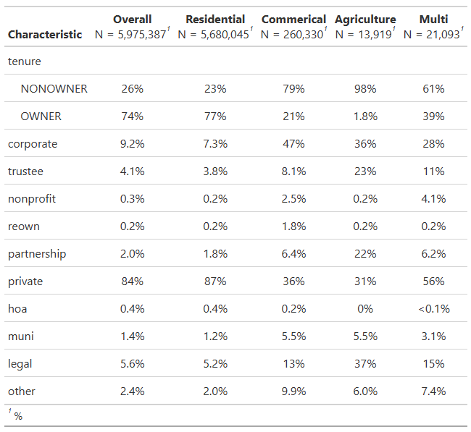
Of the almost 5.7 million residential parcels across the timeframe, seventy-seven (77%) percent are classified as owner occupied contributing to the eighty-seven (87%) percent of parcels that are privately owned. Just over seven percent (7.3%) are owned by a corporate entity with trustees accounting for the next largest share at 3.8%, followed by partnerships at 1.8%. To help simplify the analysis we combine the trustee and partnership categories into a new category called “legal” and combine the nonprofit, reown, hoa, and muni categories into the “other” category.
Figure 1 shows the share of parcels with ownership type equal to the corporate, legal, and other categories (the remaining share is private). Parcels in the other category make up a rather constant share across the years at around 2.5%. Parcels in the “legal” category see a slight increase in share across the years ranging from about 4.8% to a high of 6.3 percent of the total parcels within the county. The image clearly shows the increasing share of corporate own parcels across the years as the share of corporate owned parcels almost doubles from about 6.6% in 2010 to a high of 11.6% by 2024.
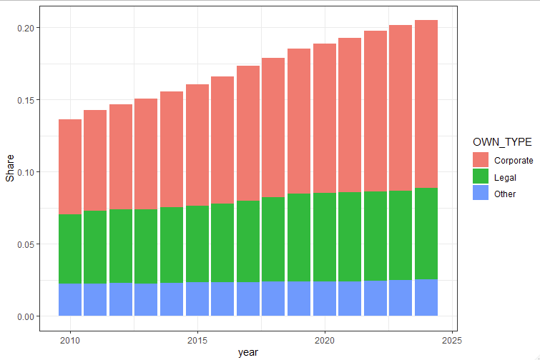

Sales Data
The county assessor’s office also tracks all property transactions within the county and maintains the core database of sales by adding any new data each year. Using the database as of 2024, we start with 930,889 with some observations reaching back as far as the 1950’s. The further back in time one goes, however, the less reliable is the data and so we limit ourselves to the 2011 to 2023 timeframe. We also limit ourselves to only arm’s length valid transactions of single-family homes with a nominal sale price greater than $1,000 which brings our observation count to 273,563 sales records.
We link this data to the ownership data by joining on the parcel identification and the year prior to the sale and the year directly after the sale year reported in the sales database. This allows us to determine the owner type and tenure before and after the sale of the given parcel. By linking this to parts of the accessor’s database that contains more detailed information about the home, we can classify homes that are sold by the builders and identify those units in the data. In cases of missing or conflicting information that we observe, we double check the ownership information using the property lookup feature hosted by the county assessor’s office on their website. We also remove any sale that has a real price above $2.5 million and then add a count for the number of times each parcel sells. These changes and removing properties with missing information results in a total of 143,300 sales remaining to work with.
The figure below shows the average real price of transactions from 2011 through 2024 for each of the four combinations of transaction tenure change. We see the largest growth in home values occur for the owner-to-owner transactions followed by the nonowner to owner type. This is expected as most literature indicates that owners occupied housing sales for a premium. Of note, however, is the strong showing and large gains in the owner to nonowner average real price, especially after 2018 when the more recent surge in corporate home buying started. Finally, transactions between non-owners see some small gains, but nothing significant indicates there are likely contributing factors behind these sales.
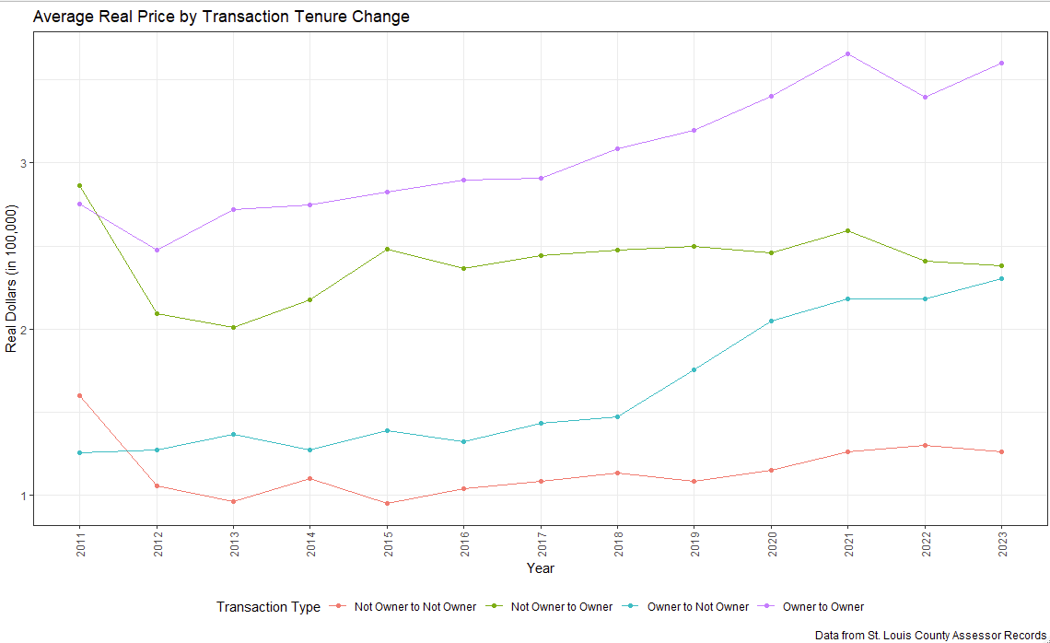
The next figure shows how the average price changes by the buyer type of the year of the sample. What is of most interest in this figure is that the legal buyers seem to be increasing in price to almost that of private buyers while corporate buyers are not seeing prices stay rather constant.

Finally, since we accept there are several unobserved factors that will complicate the analysis, we opt to utilize a repeated sales approach so that unobservable factors that are constant can be differenced out of the data. While this method is not perfect, it does allow us to focus on the key effects we are looking for in our analysis. Therefore, we remove any parcel that is only sold once in the data and limit the sales to those that occur with at least one year between the sales and remove any cases where the sale took place between the builder of the unit and the first owner. This results in a dataset with 34,812 observations across the period from 2012 to 2023.
There are fewer sales during 2012 and 2013 and we see that prices are generally falling for those two years. Part of this is that there is a smaller time between sales since the ownership data only dates back to 2011 meaning that all sales in 2012 take place within one year. We will account for this issue by estimating two samples, one with these observations and one limiting the observations to fewer years to ensure the time to sale is not driving the results. On average, the time between sales is about 3.7 years with prices generally rising across the timeframe.

By linking the ownership data to the sales data, we can determine how changes in price and time to sale change, if at all, based on the type of transaction and we tract the transaction between different types of owners. In the table below we see that 68% of all transaction occurs between two private agents which account for all the owner-to-owner transactions and about a third of the owner to nonowner and nonowner to owner transactions. Among the owners to nonowner sales, 40% are between a private owner to a corporate owner with another 26% being between private owners and legal owners such as trustees or partnerships. Conversely, among the nonowner to owner transactions, corporate to private owners account for 40% of this direction and 23% of the transactions are between legal agents and private owners. Most variation between types of owners occurs in the transactions between nonowner and other nonowners; however, a majority of these are private to private or some variation between corporate and private agents.
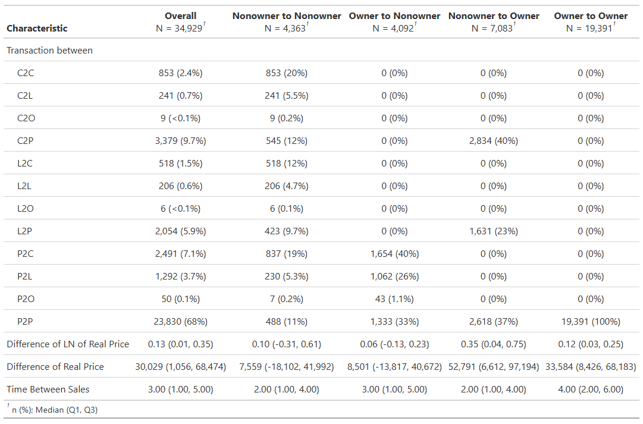
Across the transfers we see that nonowner to nonowner and owner to nonowner see the smallest gains with between 2 and 3 years elapsing between sales. Larger gains are seen in the owner to owner or the nonowner to owner transactions with owner-to-owner transactions seeing the longest time between sales of four years.

Neighborhoods
The goal of this analysis is to determine how the price gains or losses are impacted, if at all, by changes in the neighborhood between sales. Since there is no exogenous definition for what a “neighborhood” is, we create buffers equal to one-quarter, one-half, and three-quarters of a mile around each of the sold residential properties. We then intersect these buffer areas with a map of centroids for all parcels within the county to determine the ownership characteristics of the parcels surrounding the sold units. To measure how the neighborhood changes, we link the owner data for the parcels identified as a neighborhood for our transacted property in the year of the sale and calculate the share of the parcels in the defined neighborhood buffer that belong to the different ownership types and tenures.
Additionally, we link population characteristics downloaded from the ACS 5-year survey data at the tract level for each of the transacted properties. Once this data is linked to the parcels in their year of sale, we order the sales of a given parcel from oldest to most recent and then different neighborhood and census measures used between sales.
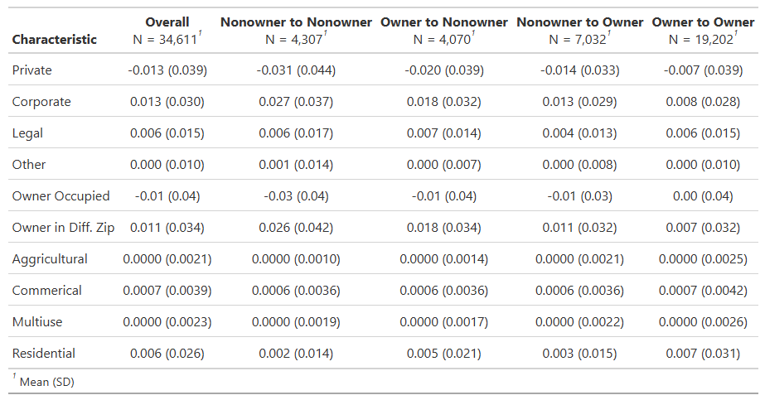
Among the neighbors in a ¼ mile radius of the transacted property, we see that the share of privately owned property dropped, on average, by just over 1.3% with drops as high as 3.3% for transactions that are nonowner to nonowner and a low of only 0.7% for transactions that are between owners. The average share of corporate owned properties also increases across sales between an average of 0.8% and 2.7% and legally owned properties increased by about 0.6%. We can also see that there was a slight decrease in most cases of the share of owner occupied homes in the neighborhood and an increase in the share of owners we reside outside the zipcode the transacted parcel resides in. While there are some changes in the land use profile around our transacted homes, there is not much of a change, all being less than 1% on average.
The next table shows the change in the population characteristics between the sale periods and the key takeaway is that there are no majors population characteristics changes among the properties within the ¼ mile radius between the two to three years of the sale of property.
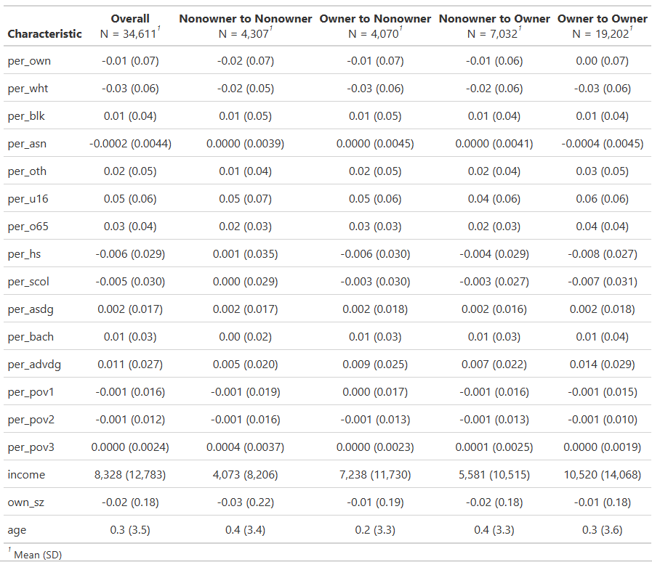

Econometric Model
We estimate a simple OLS model of repeat sales for parcels that sale at least twice during the time frame. For each period, $t$, it is assumed that the natural log of the real price of single-family home $i$ can be expressed as
 | $$lnP_{it}=α_{it}+βS_{ijt}+ιX_{i}+γN_{it}+Δ_{i}+ϵ_{it}$$ | [E 1]
In this specification, $α_{t}$ is the constant term for all homes at time period $t$, $S_{ijt}$ denotes the share of housing ownership type $j$ that is withing the neighborhood of home $i$ at time $t$. The characteristics of home $i$ is captured by $X_{i}$ and the socioeconomic and population characteristics of the census tract containing home $i$ at time $t$ is measured by $N_{it}$, $Δ_{i}$ denotes the year fixed effect for the year in which home $i$ is sold and $ϵ_{it}$ is the standard error term.
In order to avoid missing variable bias caused by the unobserved factors that are fixed across time, we difference this equation with the same equation for the same home $i$ sold at some later date, denoted as $t+n$ allowing all unit-specific fixed factors to cancel out leaving equation E2 as the estimated model where the capital subscript $T$ denotes the difference between the sale at time $t$ and at time $t+n$.
 | $$lnP_{it}-lnP_{it+n}=Α_{iT}+ΒS_{ijT}+ΓN_{iT}+Δ_{it}-Δ_{it+n}+Ε_{iT}$$ | [E 2]
At this point we estimate the model at three different neighborhood sizes, one-eighth of a mile, one-quarter of a mile, and one-half of a mile radius around the centroid of the parcel that is sold. We also cluster the standard errors at the census tract level, as defined by the 2020 census. {Note, in future iteration we do plan on clustering the standard errors at the tax district level as defined by the Saint Louis County Assessor’s Office to gain a close approximation of similar areas based on public goods and tax prices}.

Results
Table One below shows the estimates of the model with only time fixed effects and the socioeconomic and population characteristics. We allow the year 2011 to serve as the reference category given the there are only homes with an initial sale in that year since we do not allow homes sold twice in the same year to be in the data sample.
Most of the census characteristics are insignificant and among those that are significant, most seem to follow expectations with the exception of the income measure. As the median income rises, there is a slight decrease in the change in the value of the home which is opposite of what one would expect. For the percentage of white and percentage of black residents we see that as communities become more homogenous, the value of the home increases, with the racial category “other” being the reference. This gain from homogeneity does not seem to follow for the age distribution with increases in the share of the population that is sixty-five years or older show a very significant decrease in the values of a property. One concern with the socioeconomic and population characteristics results are that they area of census tract is simply too large to accurately reflect the neighborhood enough to be captured in the value of a home as expected.
Table One: Full Sample
 | Column One |  | Column Two
Characteristic | Beta¹ | SE | Beta¹ | SE
(Intercept) | 0.0808*** | 0.011 | 0.0803*** | 0.011
d_year2012 | -0.1273*** | 0.015 | -0.1216*** | 0.016
d_year2013 | -0.1813*** | 0.017 | -0.1735*** | 0.018
d_year2014 | -0.1122*** | 0.014 | -0.1011*** | 0.015
d_year2015 | -0.0953*** | 0.015 | -0.0809*** | 0.016
d_year2016 | -0.0664*** | 0.015 | -0.0467** | 0.016
d_year2017 | -0.0340* | 0.016 | 0.0320 | 0.041
d_year2018 | 0.0268 | 0.015 | 0.1070* | 0.043
d_year2019 | 0.0219 | 0.017 | 0.1187** | 0.044
d_year2020 | 0.0740*** | 0.020 | 0.1896*** | 0.048
d_year2021 | 0.1433*** | 0.022 | 0.2795*** | 0.051
d_year2022 | 0.1810*** | 0.029 | 0.3465*** | 0.057
d_year2023 | 0.2335*** | 0.033 | 0.4151*** | 0.063
income |  |  | -0.0030*** | 0.001
per_wht |  |  | 0.4448* | 0.213
per_blk |  |  | 0.5802* | 0.259
per_asn |  |  | 1.8275 | 1.19
per_u16 |  |  | 0.2732 | 0.298
per_o65 |  |  | -1.2773*** | 0.314
per_scol |  |  | 0.0825 | 0.258
per_asdg |  |  | 0.0965 | 0.376
per_bach |  |  | -0.0409 | 0.196
per_advdg |  |  | -0.2953 | 0.232
per_pov2 |  |  | -0.8615 | 0.739
¹*p<0.05; **p<0.01; ***p<0.001
Abbreviations: CI = Confidence Interval, SE = Standard Error
Standard Errors Clustered as Census Tract

One-Eighth Mile Neighborhood
Table Two below shows the results from the intercept term and the changes in the share of ownership types in the neighborhood, as defined as the one-eighth mile radius of homes around the transacted property. Column one contains a sample containing all the properties while column two only includes those properties where the buyer is an owner occupier and column three contains a sample where the buyers is not an owner occupier.
As expected we see that, all else equal, there is a slight positive increase in homes of about 8.4% which is driven by the fact that there are significantly more homes purchased by owner occupiers which, as shown in column two, sees an increase in value of about 20% whereas those homes purchased by non-owner occupiers see a loss of about 15%.
Considering the surrounding properties, a one percent increase in the share of the neighbors of a home that are owned by corporate owners results in an increase in the sale value. If we assume a one-standard deviation of increase in the share of neighbors owned by corporations, we see an increase in the value of a home of about 2.4%. Again, most of this is from the properties sold to owner occupiers given the coefficient is not significantly different from zero for those homes sold to non-owner’s occupiers. There is not, however, a premium is the share of privately owned properties change or if the share of legally owned parcels changes. There is, however, a similar premium from an increase in the share of homes that are owned by other types of owners such as municipalities, nonprofits, or bank owned properties.
Table Two: One-Eighth Mile Neighborhood
 | Full Sample |  | Owners |  | Not Owners
Changes in: | Beta¹ | SE | Beta¹ | SE | Beta¹ | SE
(Intercept) | 0.0813*** | 0.011 | 0.1882*** | 0.011 | -0.1581*** | 0.016
Share Corporate Owned | 0.8388** | 0.290 | 0.9370** | 0.300 | 0.6454 | 0.766
Share Private Owned | -0.0401 | 0.288 | -0.3507 | 0.294 | 0.0480 | 0.744
Share Legal Owned | -0.4054 | 0.249 | -0.4877 | 0.251 | -0.2703 | 0.667
Share Other Owned | 0.8357* | 0.355 | 0.6579 | 0.423 | 0.7936 | 0.694
Observations | 34,585 |  | 26,215 |  | 8,370
¹*p<0.05; **p<0.01; ***p<0.001
Abbreviations: CI = Confidence Interval, SE = Standard Error
Standard Errors Clustered as Census Tract

Table three shows the estimates from the same variable, only columns two and three split the sample by those properties where the buyer is private or the buyer is not private (any of the three other types). In this case we see the premium for the buyer being private, all else equal, is about 14% with the loss from the buyer not being private is about the same 14%. Again, we see that an increase in the share of corporate buyers in the surrounding neighborhood is, again, about 3% for a one standard deviation increase in the share of corporately owned properties. Additionally, as with the results in Table Two, we see that changes in the other types of ownership do not seem to have any statistically significant impact on the value of a given home.
Table Three: One-Eighth Mile Neighborhood
 | Full Sample |  | Private |  | Not Private
Changes in: | Beta¹ | SE | Beta¹ | SE | Beta¹ | SE
(Intercept) | 0.0813*** | 0.011 | 0.1296*** | 0.010 | -0.1290*** | 0.017
Share Corporate Owned | 0.8388** | 0.290 | 0.9871** | 0.312 | 0.3068 | 0.902
Share Private Owned | -0.0401 | 0.288 | -0.1748 | 0.295 | -0.2854 | 0.913
Share Legal Owned | -0.4054 | 0.249 | -0.4304 | 0.254 | -0.2865 | 0.791
Share Other Owned | 0.8357* | 0.355 | 0.7729 | 0.417 | 0.6117 | 0.850
Observations | 34,585 |  | 28,982 |  | 5,603
¹*p<0.05; **p<0.01; ***p<0.001
Abbreviations: CI = Confidence Interval, SE = Standard Error
Standard Errors Clustered as Census Tract

Table four adds variables measure the change in the share of the neighbors where the owner is in a different zip code from the parcel and the change in the share of the neighbors that are owner occupied. Again, we see that only the share of corporate ownership and other ownership shows statistically significant results of about two to three percent for a one standard deviation change in the share of ownership. While not statistically significant, we do notice that for properties that are sold to non-owner occupiers see a positive increase in the number of surrounding properties that are owned by landlords outside the zip code and a slight decrease in the value due to an increase in the share of owner-occupiers.
Table Four: One-Eighth Mile Neighborhood
 |  | Full Sample |  |  | Owners |  |  | Not Owners
Changes in: | Beta¹ |  | SE | Beta¹ |  | SE | Beta¹ |  | SE
(Intercept) | 0.0811*** |  | 0.011 | 0.1881*** |  | 0.011 | -0.1585*** |  | 0.016
Share Owner not in Zip Area | 0.0238 |  | 0.162 | 0.0188 |  | 0.198 | 0.3064 |  | 0.323
Share Owner Occupied | 0.2326 |  | 0.169 | 0.0762 |  | 0.179 | -0.0242 |  | 0.412
Share Corporate Owned | 0.9010** |  | 0.307 | 0.9530** |  | 0.313 | 0.4849 |  | 0.782
Share Private Owned | -0.1628 |  | 0.297 | -0.3865 |  | 0.305 | 0.1452 |  | 0.757
Share Legal Owned | -0.3576 |  | 0.260 | -0.4736 |  | 0.259 | -0.4002 |  | 0.680
Share Other Owned | 0.8930* |  | 0.371 | 0.6739 |  | 0.449 | 0.7979 |  | 0.688
Observations | 34,585 |  |  | 26,215 |  |  | 8,370
¹*p<0.05; **p<0.01; ***p<0.001
Abbreviations: CI = Confidence Interval, SE = Standard Error
Standard Errors Clustered as Census Tract

One-Quarter Mile Neighborhood
Tables five, six and seven expand the size of the neighborhood to those properties located within one-quarter of a mile from the centroid of the parcel being sold. We do see a slight increase in the premium when the share of neighbors within this larger radius are owned by agents classified as corporate owners with a premium of about 6% and, as before, the is enjoyed purely by those units sold to owner-occupiers. Also, as before, changes in the ownership of the neighbors by private or legal agents have no statistical impact on the sale price and, in the larger neighborhood radius, neither does a change in the share of “other” agent types.
Table Five: One-Quarter Mile Neighborhood
 | Full Sample |  | Owners |  | Not Owners
Changes in: | Beta¹ | SE | Beta¹ | SE | Beta¹ | SE
(Intercept) | 0.0802*** | 0.011 | 0.1865*** | 0.011 | -0.1585*** | 0.016
Share Corporate Owned | 1.9619*** | 0.529 | 2.1918** | 0.660 | 1.4511 | 0.993
Share Private Owned | 0.3444 | 0.542 | -0.0344 | 0.687 | 0.3135 | 0.982
Share Legal Owned | -0.3467 | 0.452 | -0.2805 | 0.606 | -0.6520 | 0.714
Share Other Owned | 1.2936 | 0.657 | 1.2714 | 0.922 | 0.8847 | 1.05
Observations | 34,585 |  | 26,215 |  | 8,370
¹*p<0.05; **p<0.01; ***p<0.001
Abbreviations: CI = Confidence Interval, SE = Standard Error
Standard Errors Clustered as Census Tract

Table six shows much the same when the sample is divided into those units sold to private and not private owners and table seven shows much the same when the share of owners outside the zip code are added along with the share of owner occupiers.
Table Six: One-Quarter Mile Neighborhood
 | Full Sample |  | Private |  | Not Private
Changes in: | Beta¹ | SE | Beta¹ | SE | Beta¹ | SE
(Intercept) | 0.0802*** | 0.011 | 0.1278*** | 0.010 | -0.1293*** | 0.017
Share Corporate Owned | 1.9619*** | 0.529 | 2.2339** | 0.622 | 1.2122 | 1.05
Share Private Owned | 0.3444 | 0.542 | 0.2707 | 0.628 | -0.1341 | 1.08
Share Legal Owned | -0.3467 | 0.452 | -0.1982 | 0.550 | -0.7647 | 0.795
Share Other Owned | 1.2936 | 0.657 | 1.3178 | 0.841 | 0.8514 | 1.42
Observations | 34,585 |  | 28,982 |  | 5,603
¹*p<0.05; **p<0.01; ***p<0.001
Abbreviations: CI = Confidence Interval, SE = Standard Error
Standard Errors Clustered as Census Tract

Table Seven: One-Quarter Mile Neighborhood
 | Full Sample |  | Owners |  | Not Owners
Changes in: | Beta¹ | SE | Beta¹ | SE | Beta¹ | SE
(Intercept) | 0.0802*** | 0.011 | 0.1866*** | 0.011 | -0.1583*** | 0.016
Share Owner not in Zip Area | -0.1952 | 0.274 | -0.1292 | 0.330 | -0.1023 | 0.414
Share Owner Occupied | 0.2021 | 0.319 | -0.1504 | 0.341 | 0.2116 | 0.576
Share Corporate Owned | 2.1204*** | 0.562 | 2.2068** | 0.664 | 1.5730 | 1.06
Share Private Owned | 0.1558 | 0.610 | 0.0080 | 0.722 | 0.1587 | 1.04
Share Legal Owned | -0.2306 | 0.477 | -0.2825 | 0.610 | -0.5535 | 0.766
Share Other Owned | 1.4037* | 0.670 | 1.2757 | 0.932 | 0.8866 | 1.05
Observations | 34,585 |  | 26,215 |  | 8,370
¹*p<0.05; **p<0.01; ***p<0.001
Abbreviations: CI = Confidence Interval, SE = Standard Error
Standard Errors Clustered as Census Tract

For simplicity, the buffers are center on the centroid of the sold parcel as defined by the “st_centroid()” command that is part of the sf library for R.

